Process Mapping: Simple Mortgage

# Origination Process



As-Is Process Map: *Simple Mortgage Origination Process*

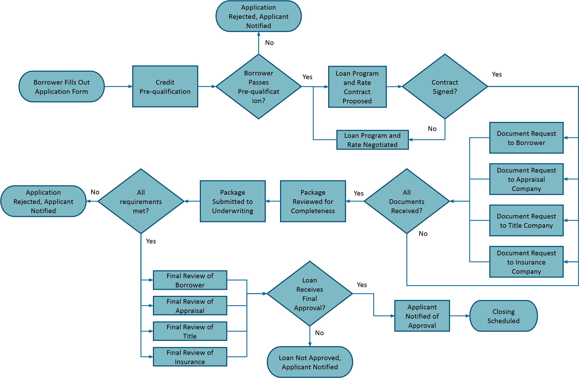

Opportunities for Process Improvement: *Simple Mortgage Origination Process*

## Process Improvement Opportunities

* Streamline Prequalification Review.
* Automate Document Collection.
* Enhance Communication with Borrowers.
* Optimize Coordination with Third Parties.
* Parallel Processing for Appraisals.
* Improve Underwriting Review Process.
* Accelerate Final Loan Package Review.
* Simplify Contract Negotiation and Signing.
* Enhance Decision-Making for Loan Approval.
* Improve Closing Process.
* Monitor and Analyze Performance Metrics.